**IFT 266 Introduction to Network Information Communication Technology (ICT)   
  
Lab 23**

**Using VLSM in Designing a Network**

Co-authored by Peter Sype

**Scenario**The following exercise will demonstrate the process to assign IP addresses using VLSM with 2 simplified campus buildings sharing an IP 192.168.69.0/24.

**Remember**  
VLSM allows a system planner to assign multiple subnet masks in the same IP address space.

1. Setup the following routers as demonstrated below (Use the Serial Ports between the routers)  
     
    You will need to add additional modules to the router i.e. HWIC-2T and HWIC-4ESW

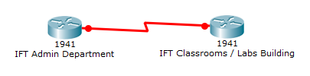



1. Add the following switches along with the labels for hosts needed.

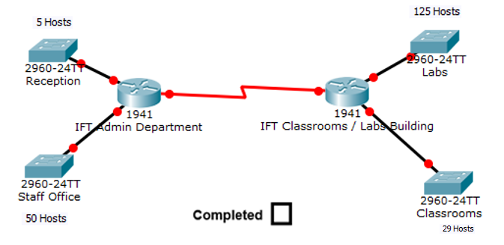

1. How many total usable hosts does our IP have available before we use VLSM to design our layout?

/24 indicates the total usable hosts of 254

What is the default subnet mask?

255.255.255.0

How many separate subnets are needed in the above topology?

5 subnets

1. In VLSM you must first identify the subnet requiring the largest allotment of IP addresses.

List the subnets by hosts from largest to smallest.

Subnet Name Hosts Needed

Labs 125 hosts

Staff Office 50 hosts

Classrooms 29 hosts

Reception 5 hosts

Link between router 2 hosts

1. Assign the subnet masks required for each subnet.

To calculate the subnet, remember that each subnet loses an IP to the Network IP and the Broadcast IP.   
  
The largest subnet requires 125 so the /26 subnet only has 30 usable IP; thus our first subnet must be /25 with the ability to hold 126 usable IP addresses.

**Network ID Usable range Subnet Mask**

Labs _192.168.69.0/25_____192.168.69.1 - 192.168.69.126_______255.255.255.128___

Staff _192.168.69.128/26___192.168.69.129 – 192.168.69.190_____255.255.255.192__

Classrooms _192.168.69.192/27___192.168.69.193 – 192.168.69.222_____255.255.255.224__

Reception _192.168.69.224/29___192.168.69.225 – 192.168.69.230_____255.255.255.248__

W1 __192.168.69.232/30__192.168.69.233 – 192.168.69.234_____255.255.255.252__

**DO NOT PROCEED TO STEP 6 UNTIL YOU HAVE COMPLETED STEP 5**

1. Open the IFT Class/ Lab Router CLI. Make sure you know the interface for both the Labs and Classroom subnets on the router.

Enter the following to setup the router interface IP for the largest Labs subnet:

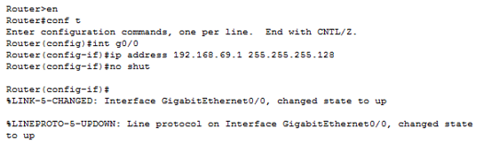



1. You should see a change in your topology.

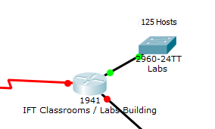



1. Complete the IP setup for the Classroom subnet.





1. Complete the IP setup for the IFT Admin Router interfaces.

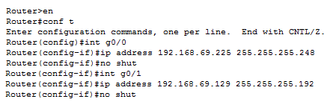

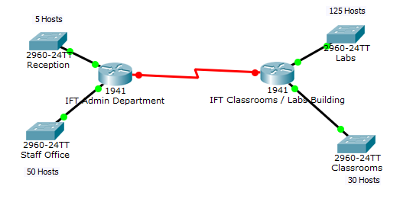



1. Always remember the link between the routers.

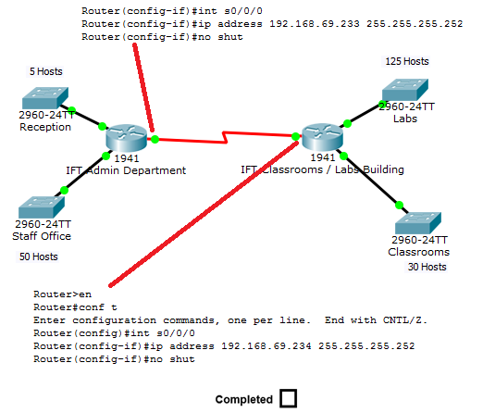

1. Add a host to the Labs subnet and a host to the Staff Office subnet.

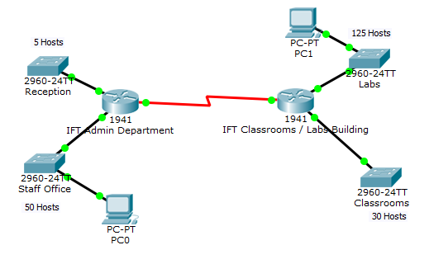



1. Plug in an IP address into the 2 PC hosts that is appropriate for the VLSM range for that subnet.  
     
   Insert screenshots of both your PC configurations below.

